Linux Terminal – Installing Software from the Repository – APT
Dan Richter
07 Sep 2020

Alright, you’ve heard me talk about installing from the repo, and you’ve probably heard others talking about it as well. So, what is a repo?

Each distribution, or in some cases, groups of distros, will create a repository that contains officially tested software programs that are known to work with their distro. For example, Debian has an official repository where they make software available to everyone running that version. Ubuntu (based on Debian) will look at what it put into Debian’s repo, and make sure it works with Ubuntu before adding it to their repo.

Since I started with Debian and Ubuntu, and these are also the most popular, let’s look at how we can access these repositories and install software. Debain, and it’s derivatives, use something called APT (Advanced Package Tool) to utilize the repositories. There is also one called APT-GET, but I believe that one is in the process of going away.

We will go over some of the commands that will help you use APT with Debian based distros. As these commands will require you to use ‘sudo’ to be a superuser, I wanted to let you know a couple things. First, after you hi enter, it will ask you for the sudo password. There are no characters echoed to the screen. Secondly, after you run a command using sudo, if you run another one within a few minutes, it will not ask you for the password each time. Don’t be alarmed by this. It is to keep you from having to type it in 15 times in 2 minutes, as some of us would end up doing.

sudo apt update

Before you do anything with the repositories, you will need to make sure your local database is updated to what is on the servers. When you run ‘sudo apt update’, your computer will contact all of the databases that are set up on your system, and make sure it has the current information. Yes, you will need to use ‘sudo’, as this will need to be run as a superuser. Most of the software you install, will end up in directories managed by Linux, and not in your /home directory.

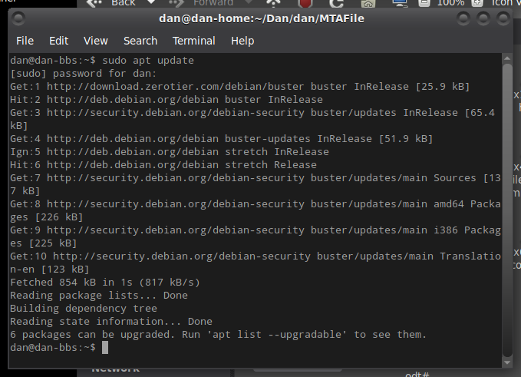

If you look at the above output, you will see the computer contacted all of those servers, and updated it’s list of current software and versions. It also keeps track of any dependencies that the software might require.

The last line, says there are 6 packages that can be upgraded. If you were to run the ‘sudo apt list –upgradable’, it would just give you a list of what these 6 packages are.

sudo apt upgrade

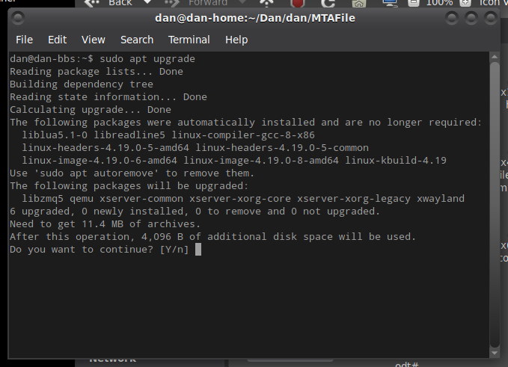

This command will also give you a list of the 6 packages that can be upgraded. It will then ask you if you want to install these now.

Once you hit Enter, or Y, it will install all 6 of the upgradable packages. This process can take some time based on how many upgrades there are at the time.

sudo apt search <package_name>

This command will search the local database of packages available, and try to find the program you are looking for. If you are looking for a program called mplayer, you would type in ‘sudo apt search mplayer’.

The screen will show you all of the matches that even come close to what you are looking for. You may only have 1 or 2 listed, or you may get 500 matches, depending on your search.

sudo apt install <package_name>

After you find the package you’re looking for, you can type in ‘sudo apt install mplayer’, and apt will install the software you chose.

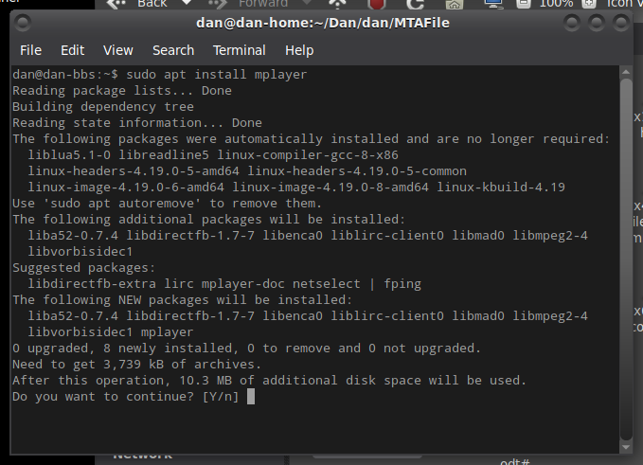
sudo apt remove <program_name>

If you decide that the program you installed either wasn’t what you thought it was, or doesn’t work they way you’d like, you can remove it. If the mplayer package we just installed isn’t what you wanted, we can type in ‘sudo apt remove mplayer’, and apt will remove the package.

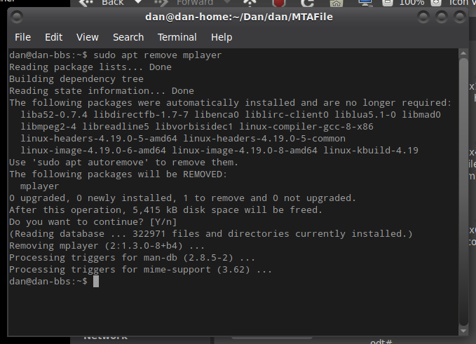

That’s the basic commands to use APT for any of the Debian based distributions. There are many other switches that can be used to manage your system.

